Thomas McCarthy
ENC1101-48
Ms. Charla Hughes
20 November 2012
Call of Duty Anti-Ad
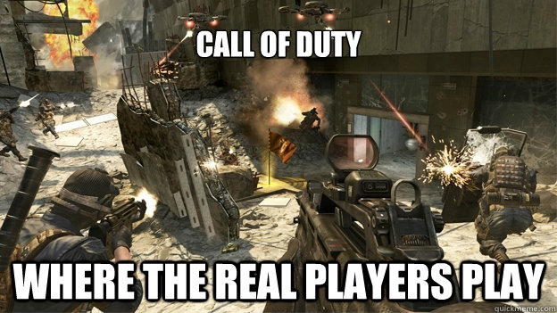
The Call of Duty franchise has slowly risen to become the crown jewel of gaming and it is now a money making machine. In the past three years each new installment has grossed over a billion dollars. One of the key reasons that is attributed to Call of Duty’s success is that it’s tailored to gamers that have a low level of experience making it a game that is playable by almost anyone. Because of Call of Duty’s simplicity, there have been many jokes in video game community on how easy Call of Duty is. If one was to talk to hardcore gamers they would completely dismiss Call of Duty as being a competitive game that requires skill. A recent game that has been attacking Call of Duty is the highly popular Battlefield franchise. Battlefield and Call of Duty have been battling each other over which game holds the title of Best Shooter. A year ago when Battlefield 3 came out one of their ad campaigns had the tagline “Rise Above the Call” implying gamers to play a game that is better than Call of Duty. To combat the belief that Call of Duty is a simple game that only young children play, I created a meme to give a visual element and a tag line for a new ad campaign. The anti-ad will be a commercial that will feature high tense moments of actions, explosions, lots of gunfire, and amazing sniper shots. The commercial will then end with four members from FaZe clan, a professional Call of Duty clan, claiming support for Call of Duty, and finally the tag line will appear, “Call of Duty, Where The Real Players Play”.
Activision, the publisher for Call of Duty, has millions of dollars that they can spend on advertising and because of that, they are able to have several successful ad campaigns. However, Activision has yet to target professional gaming in their ad campaigns. Activision’s campaigns almost always target the broad general audience, but they never seem to focus on pro gamers. This is where their commercials fall short because there has been an increase in popularity for pro gaming. Major League Gaming, or MLG, has pushed professional gaming by hosting tournaments in several games including Halo, Starcraft II, and recently Call of Duty. Activision last year hosted an LA L.I.V.E Call of Duty tournament, in anticipation for the release of Call of Duty Modern Warfare 3, where the best players in the world competed for a winning prize of $400,000. Since tournaments are team based, there have been professional clans formed such as FaZe that compete in several big tournaments throughout the year.
FaZe is currently one of the best clans in the world and in their clan they have highly skilled players that are exceptional Call of Duty players. They’ve won several large tournaments in recent years and established themselves as a powerful clan. Clans, like FaZe, have made professional gaming reach a new level where it is getting increasingly harder and harder to become a pro gamer. For my ad campaign I would use FaZe’s reputation to my advantage and have them featured in the commercial to show other gamers that Call of Duty is the game that you want to play if you want to reach high levels of competitive gaming.
The commercial for my anti-ad will promote the multiplayer aspect of Call of Duty. The commercial will be approximately be a minute and fifteen seconds in length. Multiplayer is by far the most popular component in the Call of Duty games. FaZe clan has uploaded on YouTube several incredible videos that almost seem impossible. Inspired from these videos I would compile clips from various clans showcasing how much fun multiplayer is. For the first thirty seconds of the commercial, I would use scenes like the one from the meme where there is a lot of gun fire, explosions, and everything seems chaotic which will add a level of excitement to the commercial. This will mostly comprise of run and gun type of gameplay that made Call of Duty so much fun in the first place. The commercial would move from highly congested close quarters combat to more of long range battle scenario where you see sniper kills.
Not only has FaZe built itself as one of the best clans in the world, but they have also established themselves as amazing snipers. The next thirty seconds will be exclusively sniper kills. FaZe absolutely loves to show off in their videos by jumping off of buildings while spinning in mid-air and without scoping their sniper rifle they fire at the enemy, somehow getting the kill. This may seem completely exotic and hard to understand for most people, who do not play Call of Duty, but this is one of the most difficult shots to make. Of the twelve million or so people who play Call of Duty, less than ½% of people are able to make these shots. I would include some clips from FaZe that give will give a “WOW! I can’t believe he just survived that” factor to the audience where they are left speechless to what they just saw. Although this may be hard to understand, anybody who plays Call of Duty will be able to understand how difficult and amazing some of the next couple shots will be. The purpose of this segment of the commercial is to show hardcore gamers that there are people who play Call of Duty who are exceptionally great at Call of Duty. This neglects the exaggerated belief that only “little” kids play Call of Duty. By including professional gamers in this commercial it goes to show that there are highly skilled players that play Call of Duty.
The last fifteen seconds of the commercial will be four FaZe members wearing FaZe gear. They will all basically do a small introduction saying their latest championship victory and saying how they’re responsible for the previous clips seen on the commercial. The team captain of FaZe will go on to say “We are a pro gaming clan and we play Call of Duty”. The commercial will black out and then the words “Call of Duty Black Ops II” along with the logo will come on and you will hear the tag line “Call of Duty. Where the Real Players Play” in a strong voice extinguishing any doubt that people only people with low skill and experience play Call of Duty.
The Call of Duty franchise has had a history of several successful advertisements that appeal to a huge amount of people. The one area that they target less is hardcore gamers. The style of each Call of Duty game and the simplicity of it, has made the game a joke in the video game community. On top of an overwhelming amount of little children who play the game, makes it seem as if only inexperienced gamers play the game. Additionally with games such as Battlefield 3 placing a heavy emphasis on realism and skill in order to be good, hardcore gamers now view Call of Duty as an overly simplistic game that has no potential of reaching high levels of competitiveness. The anti-ad that I developed is a commercial that supports Call of Duty as a great location for pro gaming and intense competition by showcasing amazing sniper kills that can only be done by professional gamers. The commercial will also include the professional gaming clan, FaZe, supporting Call of Duty Black Ops II saying that this is the game that they play. This anti-ad critiques Activision’s neglect of professional Call of Duty players. Most new Call of Duty ads are completely targeting new players and Activision seems to forget the fans that made Call of Duty the most successful franchise in gaming history. This anti-ad tailors to both newcomers by giving them a sense of what Call of Duty is, in the beginning portion of the ad. The ad also recognizes Call of Duty as a game that can also be played by hardcore gamers since it shows amazing professional sniper kills from FaZe. The commercial ends with tagline “Call of Duty. Where the Real Players Play” establishing itself as a game that can be played by both newcomers and professional gamers alike.

